Background Part 2 (Computer Organization & Operating System)

Computer Organization

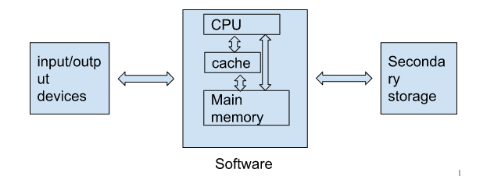

DESIRABLE FEATURE OF MEMORIES

* Low Access Time
* Low Cost
* High Capacity

CACHE - Cache memory have very low access time, high cost and low capacity. It is volatile

MAIN MEMORY - Main memory is moderate in all three term. It is volatile.

HARD DISC - High Capacity, low cost and high access time. It is permanent storage.

The task of bringing the data from hard disc to memory is done by operating system.